A shopping Cart SyStem

Proposed By Mike Zhi Yu and Elmira Aamanollahi

April 8, 2017

## Project Description

This project is a using C# and WPF or other .net language or framework to finish an online shopping cart system, which includes item display windows, item description for each item, shopping cart, and billing window for price and total price. The system is connected to the database, which has item inventory, sold item summary, item price tables and profit table. The database is upgraded after each shopping case, there is a trigging function for those item’s amount in stock get lower than limit value, a popup windows will come out to remind user to order more items. We will also develop a graphic application for presenting sale statistic. A simple calculator will be embedded in the windows. The shopping case and bill is printable or save as PDF file.

## Project Requirements

The project will be designed by WPF framework and C# language in Visual Studio 2013. The database will be used MS-AZURE cloud database. Our team members can communicate in person or by Git every day. The version control is in Git too. All class or important method will be validated by UI test,

## Technologies We May Use

* WPF, C# within Multiple windows
* SQL Database via Azure
* Drag and drop
* StackPanel, GridSplitter
* PDF-generation and Printing
* WebAPIs client and LINQ
* Drawing on canvas (e.g. Charts with data) via custom libraries
* Graph interface

## Some Screenshots and Captions in Design

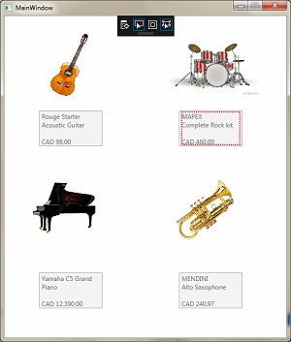

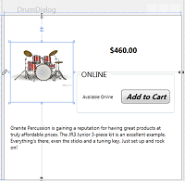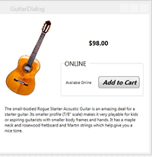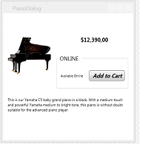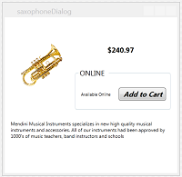

User Selects One of the Items above in **main window**, then related **dialog** will pop up, In Pop Up window the description of the product exists. To buy the item user will click on **Add to Cart Button** and then **billing dialog** shows up which contains items, total cost and calculator. Customer will be able to **print** her invoice.

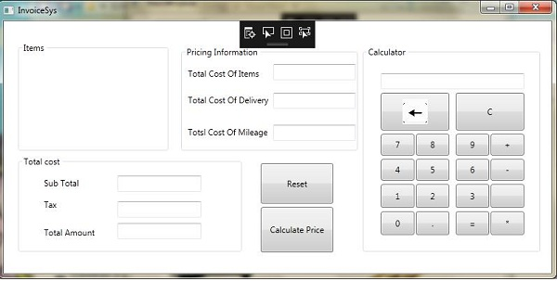

## DataBase Diagram

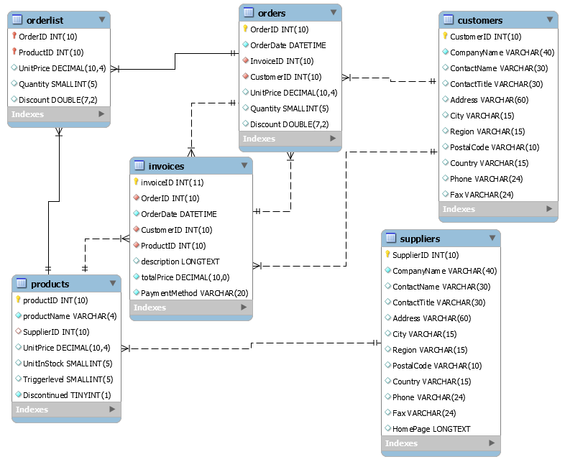

Above Diagram indicates relationship of database we will use in MS-Azure, the table shopping is directly connected to the WPF after each shopping, where the information of customer, item are related. The new customer will be created in the table customers, the item stock in table items is upgraded as shopping is done. The WPF will read the amount of item in stock from table items and see if a trigger occurs (we will not add trigger action in database).

|  |  |  |  |  |  |  |  |  |
| --- | --- | --- | --- | --- | --- | --- | --- | --- |
|  |  |  |  |  |  |  |  |  |
| Approved By |  |  | Date |  | Approved By |  |  | Date |